BIRCH RE Home Learning Due: 6th May
Your topic for RE this half term is: How do Christians show their belief that Jesus is God incarnate?
Christians believe that God came into the world as a human in the person of Jesus Christ. He was both totally human and totally holy!
Christians sometimes call Jesus ‘Emmanuel’ because it means ‘God with us’.

ARTS AND CRAFT or COMPUTING TASK: Create your own Word Cloud with names for Jesus or words that you think describe him. You can either do it online (try googling Word Cloud) or by hand (paint, felt tips, pencils, collage, bubble writing).

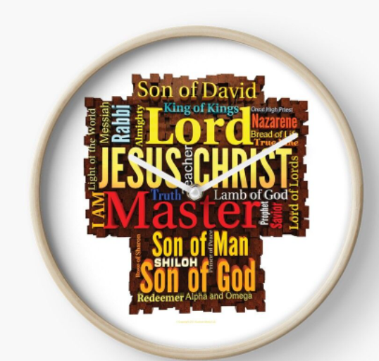
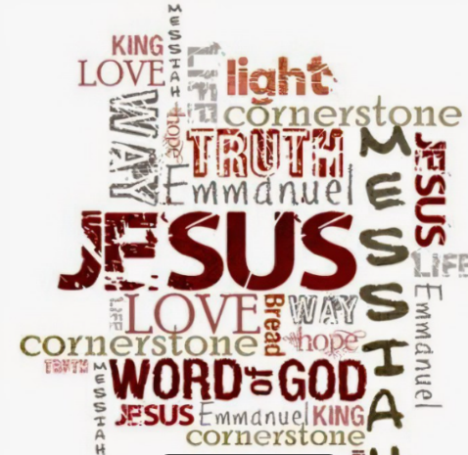
Have a look at these examples.

It is completely up to you which words you choose to describe Jesus. People have different opinions so Mr Palmer won’t be marking these as either right or wrong. We are interested to see what these look like

