BIRCH RE Home Learning Due: 13th May
DISCUSSION: Have a look at this painting… and talk to someone at home about what you can see.
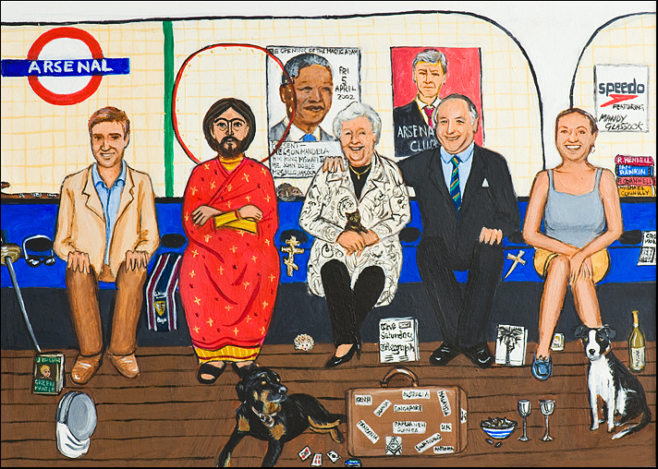
Last week, you wrote some words to describe Jesus.
Imagine that the same Jesus that you wrote about actually came to our school…what would it be like?!
Where would he stand in our school to get to know people and so they could get to know him? Complete one (or both!) of the following activities…
ART ACTIVITY: Draw a picture of Jesus in our school. You can draw yourself and your friends in it too.
WRITING ACTIVITY: Write a short diary entry, imagining you have just seen Jesus at school!

