CHESTNUT RE Home Learning Due: 13th May
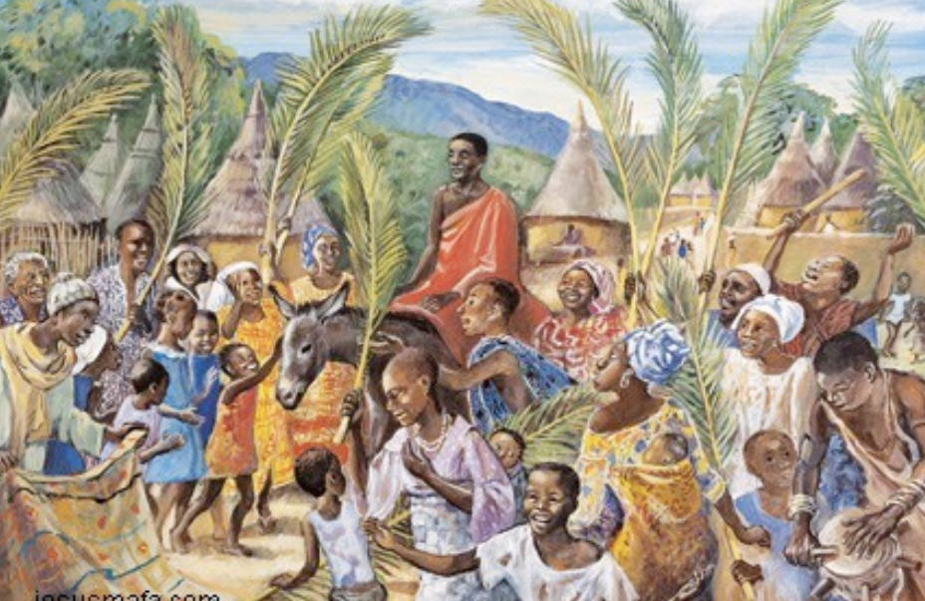
Chat about the questions below…you might have different answers.
Have a look at this painting and chat about it with someone at home.

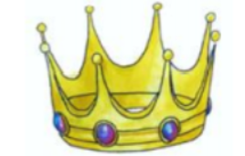

Which story from The Bible could it be?
Who is the person in orange and
what are they doing?
What do you think is happening?
What might some of the people be
saying or shouting?
Have you got any questions about the painting or the story behind it?

