OAK RE Home Learning 6th – 13th May
INFORMATION FOR PARENTS AND CARERS
In Years 1 and 2, children explore themes linked to religions (believing and belonging). The focus for this half term is: Pentecost and the Holy Spirit.
There are no right or wrong answers to the three questions below. In school, we would encourage the children to say what they think and record their responses – whatever they say. Your child/ren will learn more about the quotes (from a Christian perspective) in their RE lessons in school.

Your topic for RE this half term is about Christians celebrating Pentecost!

GAME – Play Hide and Seek! Cut out these messages and ask someone to hide them around your home. See if you can find all 5 of them!
I am going to the Father. | Wait for the gift I told you about. | When the Holy Spirit comes, you will be filled with power and be witnesses for me all over the world.
When I go, you will not be left all alone. | I will ask the Father and he will give you another Helper, the Holy Spirit, who will stay with you forever.

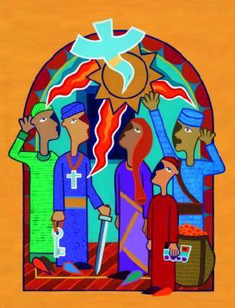
Afterwards chat to someone at home –

1. Who do you think might have said these words?
2. What do you think they mean?
3. Are there any words that you don’t understand?

