ASH RE Home Learning 6th – 13th May
INFORMATION FOR PARENTS AND CARERS
Following on from last week, this video helps children to gain a brief understanding about another world religion: Sikhism. Please watch it together with your child and talk about it afterwards.
The link is here: BBC iPlayer - Whats on Your Head? - Series 1: 4. Turban
https://www.bbc.co.uk/iplayer/episode/m000sfht/whats-on-your-head-series-1-4-turban
If link doesn’t work, google “CBBC What’s on your head?” It is Episode 4.

Week 1. Episode 2 – Hajib

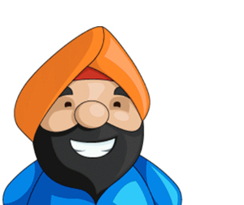
Do you know what this man is wearing?
Watch the video to find out more.

Raj is a Sikh and he is wearing a turban.

