OAK RE Home Learning 13th – 20th May
INFORMATION FOR PARENTS AND CARERS
In Years 1 and 2, children explore themes linked to religions (believing and belonging). The focus for this half term is: Pentecost and the Holy Spirit. Tom and Tessa are two characters who teach the children about the Christian faith.

Read the letter from Tom below…
Hi everyone! Tessa and I are glad that God is with us always. But sometimes we forget God’s good ways and we do something we shouldn’t. Does that happen to you sometimes too?
When Tessa and I pray to God for help, he helps us to do the right thing. The Holy Spirit is like an invisible friend who is real. He warns us when we are wrong but we don’t always want to listen to God’s ways. Other times we listen and ask God to help us and that’s when these special ‘Fruits of the Spirit’ start to grow in us.
Which of the fruits do you think it is best for us to try to grow in?

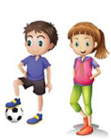

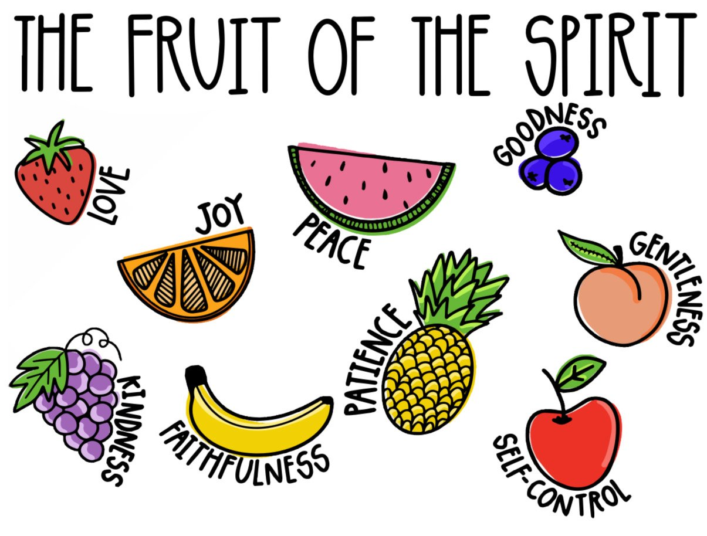

Make a picture of a piece of your favourite fruit. You could draw it, paint it, make a collage or design it on a computer.
On the back of the card, write which of the ‘Fruit of the Spirit’ you think Tom and Tessa should try to grow in.
Which fruits do you think you have? Ask someone at home too!

