ASH RE Home Learning 13th – 20th May

INFORMATION FOR PARENTS AND CARERS
Following on from last week, this video helps children to gain a brief understanding about Christianity. Please watch it together with your child and talk about it afterwards. The link is here: BBC iPlayer - Whats on Your Head? - Series 1: 7. Bishop Mitre
https://www.bbc.co.uk/iplayer/episode/m000slhd/whats-on-your-head-series-1-7-bishop-mitre
If link doesn’t work, google “CBBC What’s on your head?” It is Episode 7.

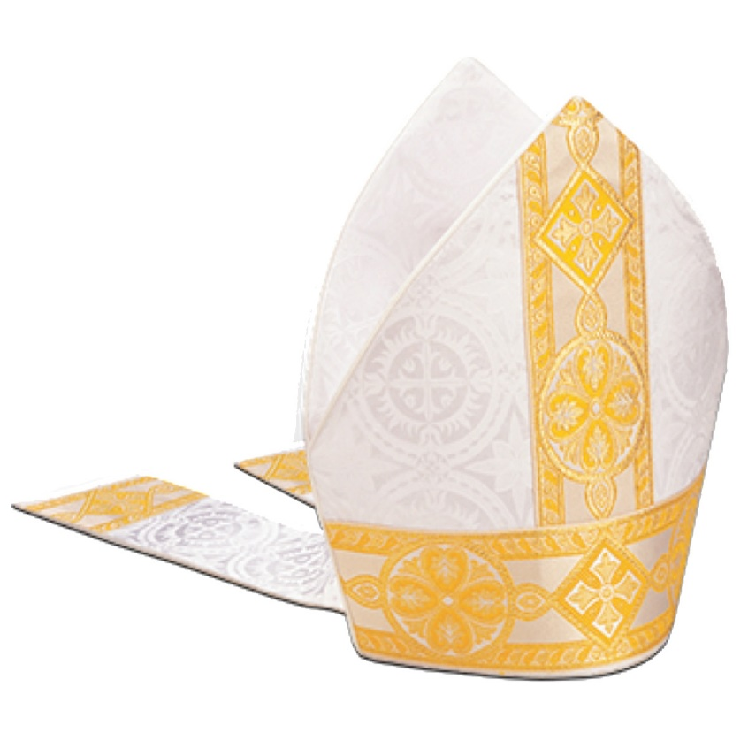
Do you know what this is?
Where might you put it?
Who might wear it?

Watch the video to find out!

Afterwards, you could try making your own mitre out of paper or card.

