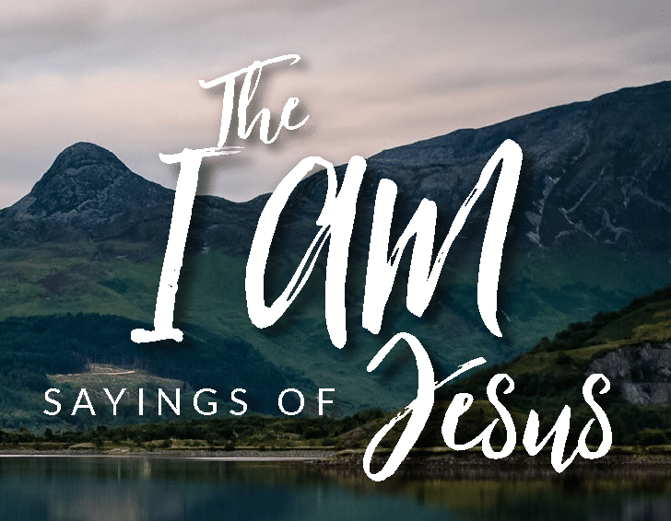
BIRCH RE Home Learning Due: 27th May

In John’s Gospel, Jesus refers to himself as seven different things by saying “I am…” Here are four of them. Draw a mini picture for each one and have a think about what Jesus means when he refers to himself in this way…
Jesus says… | Mini Picture | What do you think Jesus meant when he said this?
“I am the Light of the World”

John chapter 6 verse 35

“I am the Bread of Life”

John chapter 8 verse 12

“I am the Good Shepherd”

John chapter 10 verse 14

“I am the Way, the Truth and the Life”

John chapter 14 verse 6

