OAK RE Home Learning 20th – 27th May
INFORMATION FOR PARENTS AND CARERS: In Years 1 and 2, children explore themes linked to religions. The focus for this half term is: Pentecost and the Holy Spirit.

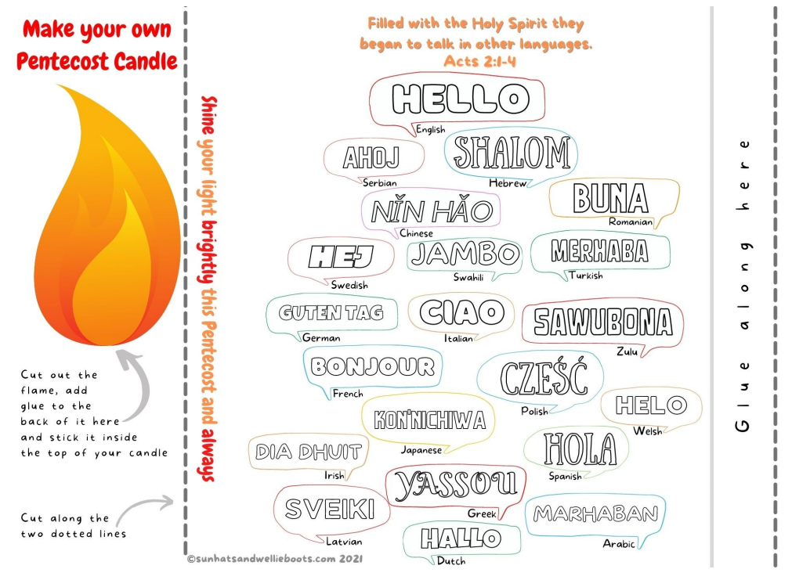
Make a Pentecost Paper Candle. Colour it in and learn to say Hello in different languages.
Ask someone at home to help you with the cutting and sticking.
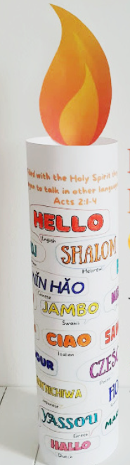
When you have made your Paper Pentecost Candle you could make your Pentecost Candle 'light up' by placing a battery tealight in the base of it. Watch how the colours of 'hello' glow in the dark.

