ASH RE Home Learning 20th – 27th May

INFORMATION FOR PARENTS AND CARERS
This video helps children to gain a brief understanding about Judaism. Please watch it together with your child and talk about it afterwards. The link is here: BBC iPlayer - Whats on Your Head? - Series 1: 9. Kippah
https://www.bbc.co.uk/iplayer/episode/m000snhj/whats-on-your-head-series-1-9-kippah
If link doesn’t work, google “CBBC What’s on your head?” It is Episode 9.

I wonder what this man is wearing. What symbol can you see on it?

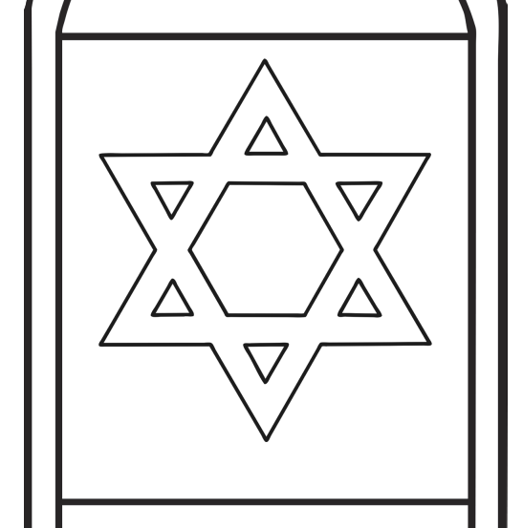
Watch the video to find out.

You might want to colour in this Jewish symbol.

