Noah is important in Judaism, Islam and Christianity. This half term, Chestnut class will be learning about Judaism and answering the question: What symbols and stories help Jewish people remember their covenant with God?
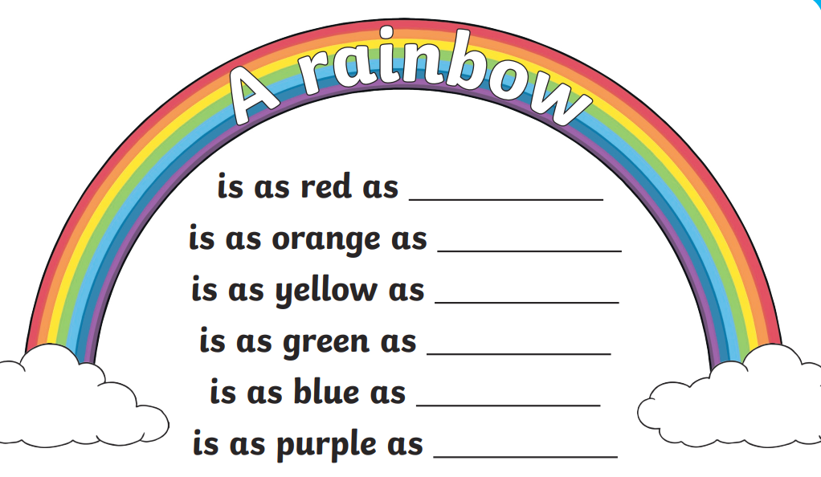
The Rainbow is an important part of the story of Noah. Have a go at writing a RAINBOW poem.

