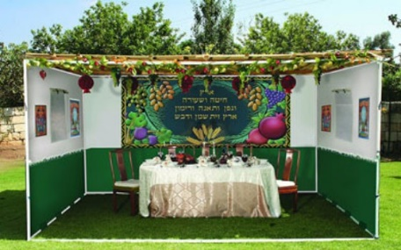
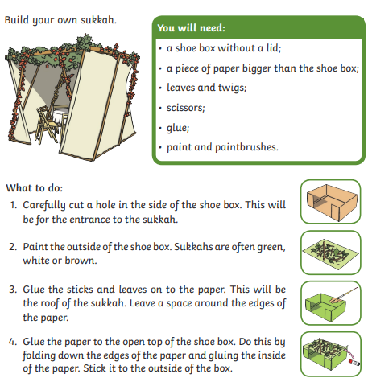
Oak class are learning about Judaism and the question: Why do Jewish families say so many prayers and blessings? Sukkot is the Jewish Harvest Festival. As part of their celebrations, Jews build special tents called Sukkahs and they spend lots of time during Sukkot in the Sukkah.

Have a go at building a mini Sukkah. Ask an adult at home to help you! After, take a photo of it or bring it into school.

